

**Did you know…**

**You don’t have to call our reception team to access a range of services?**

**On our website you can:**

* **Order repeat prescriptions**
* **Cancel appointments**
* **Change your personal details**
* **Tell us if you are a carer**
* **Complete a range of forms (such as Travel Questionnaires for Travel Immunisations, self-refer to the midwife etc.)**

**Visit our website at https://www.alcesterhealthcentre.co.uk/**

**Practice News**

**Re-Introducing Birthday Recalls for Chronic Disease Management**

**From April 2022, we are re-introducing birthday month recalls for annual reviews of certain medical conditions.**

**We have decided to re-implement this schedule, which has become slightly out of sync due to the Covid Pandemic.**

**However, with these changes in place it may appear the time from your last review to your next review is more or less than 12 months. This enables us to transition to birthday month reviews over the coming months.**

**If you have a long term condition such as Diabetes, Asthma, Hypertension, Stroke or COPD, etc., you will receive an invitation to book your annual review with the practice during your birthday month either by text or letter asking you to contact the practice.**

**A Chronic Disease Management appointment is required for certain conditions, and this will include a mini-health screen which will include your height, weight, pulse check, blood test (if required), blood pressure, and lifestyle information. This will provide us with general information about your health to monitor your care.**

**You will then be requested to book a follow up appointment for an annual review discussion with a Practice Nurse, GP or Clinical Pharmacist. As appropriate to your condition.**

**Long Covid Support**

**How long it takes to recover from COVID-19 is different for everybody.**

**As you find yourself recovering from COVID-19 you may still be coming to terms with the impact the virus has had on both your body and mind.**

**Visit** [www.yourcovidrecovery.nhs.uk](http://www.yourcovidrecovery.nhs.uk) **for advice and support or if you require further support contact the practice to book in with a clinician.**

**Covid-19 Queries**

**If you have any queries regarding Covid-19/ Booster vaccines please ring the surgery and choose option 6.**

**An automated message shall provide some generic information, however if your question is still unanswered, please hold and you will be transferred to a local helpline!**

**Book online for your Covid Vaccination via nhs.uk/CovidVaccination or go to a walk-in vaccination site**

**Covid-19 and our Face Mask Policy**

**Thank you for your continued respect to our policy, for Face Masks to be worn on the surgery premises.**

**We continue to ask our patients to help us with this, to continue to keep other patients and our staff safe.**

**New Telephone System**

**As you may be aware our new telephone system went live at the start of March. We hope that you have noticed an improvement in the efficiency of this system!**

**We received feedback with our previous system that it would be beneficial to have a queuing structure in place. Therefore, our new telephone system enters callers into a queue, informing callers how many people are ahead of them.**

**In addition a call back option has been implemented, when the phone lines are extremely busy. This gives callers the chance to receive a call back when they are at the front of the queue.**

**Thank you for bearing with us whilst we introduced and learnt the new telephones!**

**Keep Updated with Surgery News**

**Like and follow our Facebook Page to stay up-to-date with surgery news!**

**@AlcesterHealth**

**The page is frequently**

**updated with useful**

**surgery information.**



**NHS 111**

**If you need medical advice when the GP surgery or the pharmacy is closed, call:**[**111**](tel:%20111)**or go to**[**111.nhs.uk**](https://111.nhs.uk/)

**E-Consult**

**E-Consult is the most widely used digital triage tool in NHS primary care, built by NHS GPs for NHS patients!**

**E-Consult allows patients to submit queries without the need to wait on the phone. It is available Monday to Friday between 07:00 and 16:30**

**This service can be used for requests for appointments, sick notes, and other administrative queries can be accessed via this pathway!**

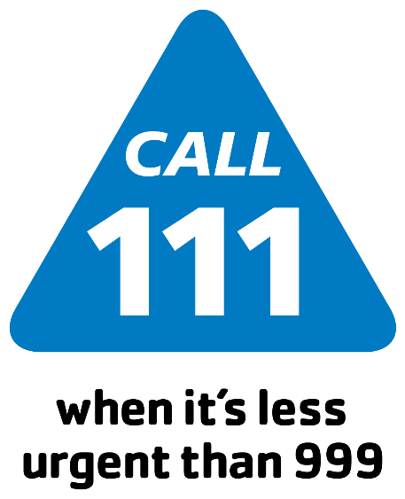

**Have you got the NHS App?**

**Wherever you are, the NHS app allows you to book, cancel and track appointments at your GP surgery with ease.**

**You can conveniently order repeat prescriptions, view your GP medical record, and quickly check symptoms, plus access to NHS 111 online means no more wondering if you need urgent attention. It’s free and owned by the NHS so you know your personal data is always secure. You can find it in in Google and Apple app stores. Simplify your life. Download the NHS App!**

**Appointment Check In**

**You can check-in using your mobile phone. Simply scan the QR code that is displayed on the reception.**

**Hayfever**

**Did you know you don’t need to see your GP to get hayfever treatments?**

**Your local Pharmacy can help, and are now able to sell stronger hayfever medication, that was once prescription only, over the counter.**

**Join Alcester Health Centre Patient Participation Group (PPG)**

**The PPG aims to be the voice of the patient in the practice. Working constructively and positively to help identify solutions and work in partnership with the practice.**

***If you would be interested in joining the PPG please complete the form on the Practice Website***